Experiment No: 05
Experiment Name:
- Write an assembly language program to print letters A to Z using EMU8086.
- Write an assembly language program to display a row of 80 stars using EMU8086.
- Write an assembly language program to print a 5 × 5 matrix using EMU8086.
Theory: EMU8086 assembly handles repetitive output using loop instructions combined with DOS interrupts. To print letters A to Z, load 26 into CX as the counter, set AH to 2, place 'A' in DL, and call INT 21H inside a loop that increments DL each iteration. To display 80 stars, load 80 into CX, set AH to 2, place '*' in DL, and call INT 21H repeatedly until CX reaches zero. To print a 5×5 matrix, define a string with five stars and a newline terminator in the data segment, load 5 into CX, set AH to 9, point DX to the string, and call INT 21H inside a loop. The loop instruction automatically decrements CX and jumps back until the count finishes, making repetition efficient. Strings for function 09H must end with '$' to signal termination to the DOS interrupt handler. Finally, load 4CH into AH and call INT 21H to terminate the program and return control to DOS.

Code & Output:
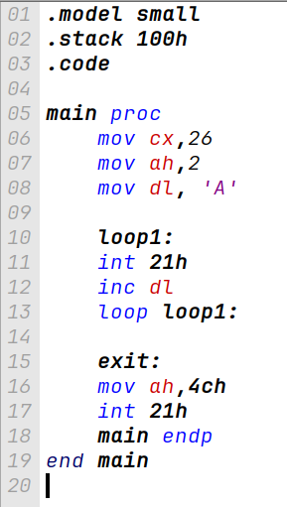
i) Code to print letters A to Z:

B9 1A 00 B4 02 B2 41 CD 21 FE C2 E2 FA B4 4C CD 21
Machine Code:
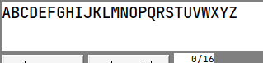
Output:

ii) Code to display a row of 80 stars:
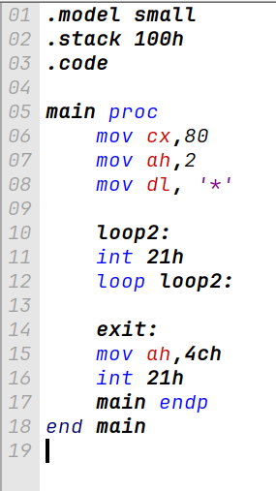

B9 50 00 B4 02 B2 2A CD 21 E2 FC B4 4C CD 21
Machine Code:

Output:
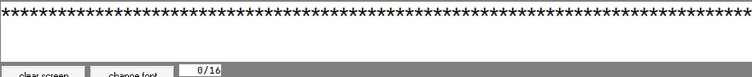

iii) Code to print a 5 × 5 matrix:

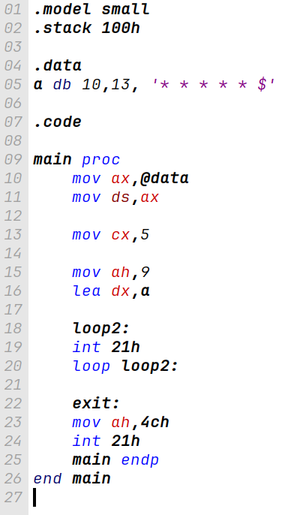

B8 20 07 8E D8 B9 05 00 B4 09 BA 00 00 CD 21 E2 FC B4 4C CD 21
Machine Code:

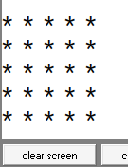
Output:

Conclusion:
The program was executed successfully in the EMU8086 environment, and no errors were found. We successfully learned 3 assembly language program respectively print letters A to Z, display a row of 80 stars and print a 5 × 5 matrix.We also learned a new method of printing new line in assembly language program.

